Part B
Schools and Resilience

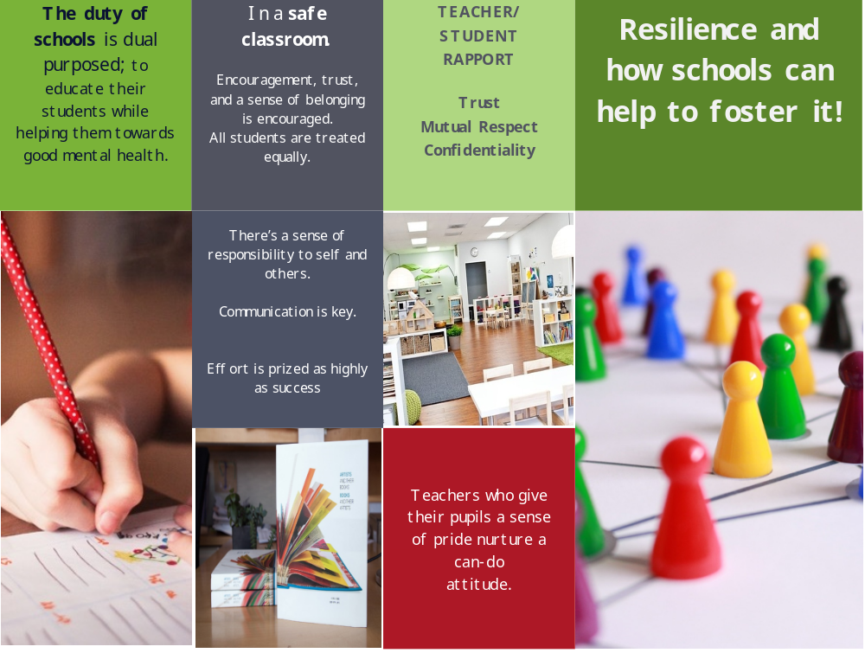
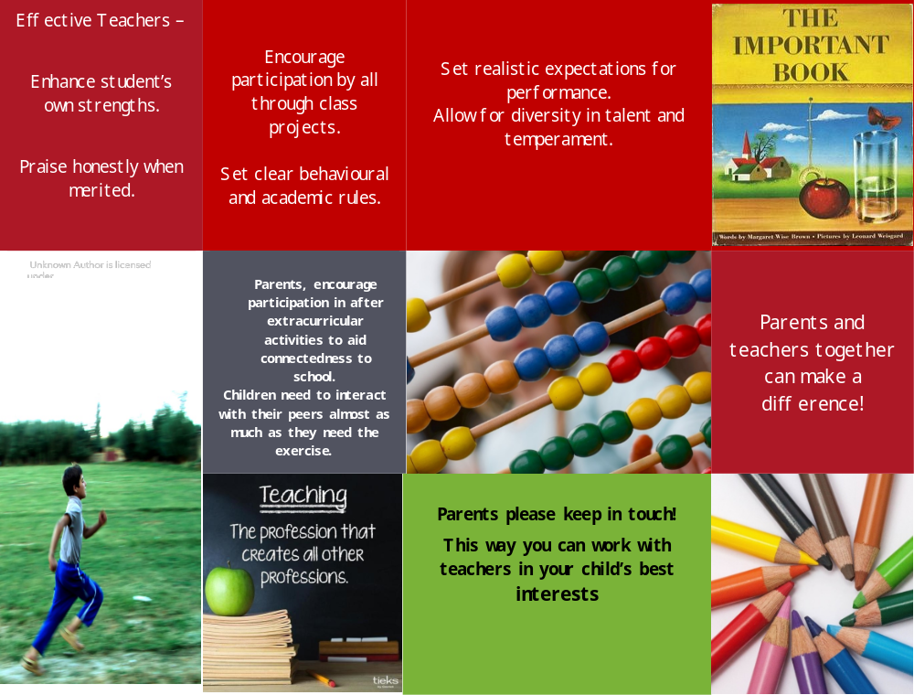
References

Downey, J. A. (2008). Recommendations for fostering educational resilience in the classroom. Preventing School Failure, 53(1), 56–64.
https://doi-org.dcu.idm.oclc.org/10.3200/PSFL.53.1.56-64

Howard, S., Dryden, J., & Johnson, B. (1999). Childhood resilience: Review and critique of literature. Oxford Review of Education, 25(3), 307–323.
https://doi-org.dcu.idm.oclc.org/10.1080/030549899104008

Stewart, D., Sun, J., Patterson, C., Lemerle, K. & Hardie, M. (2004). Promoting and building resilience in primary school communities: Evidence from a comprehensive ‘health promoting school’ approach. International Journal of Mental Health Promotion, 6(3), 26-33.
https://doi.org/10.1080/14623730.2004.9721936

